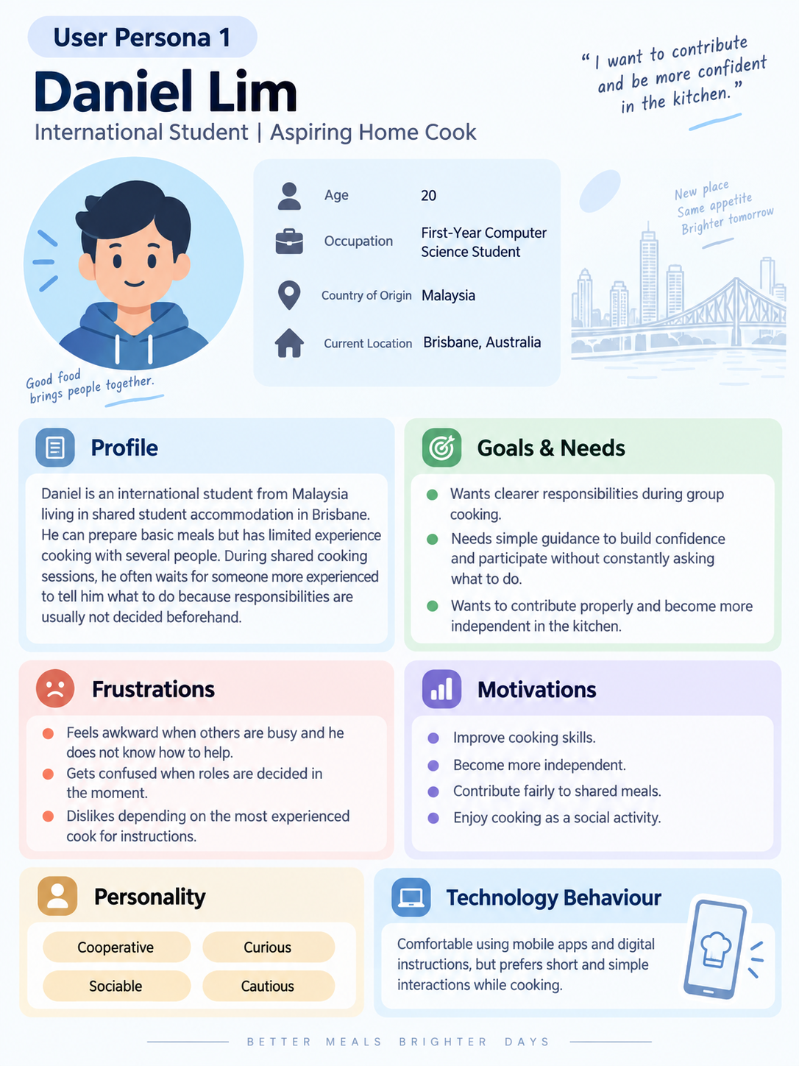

Theme 1 — Daniel: No Plan Before Cooking Starts
User Story:
As a less experienced cook, I want cooking tasks to be decided before we start, so that I know what I am responsible for and do not have to wait for someone to tell me what to do.

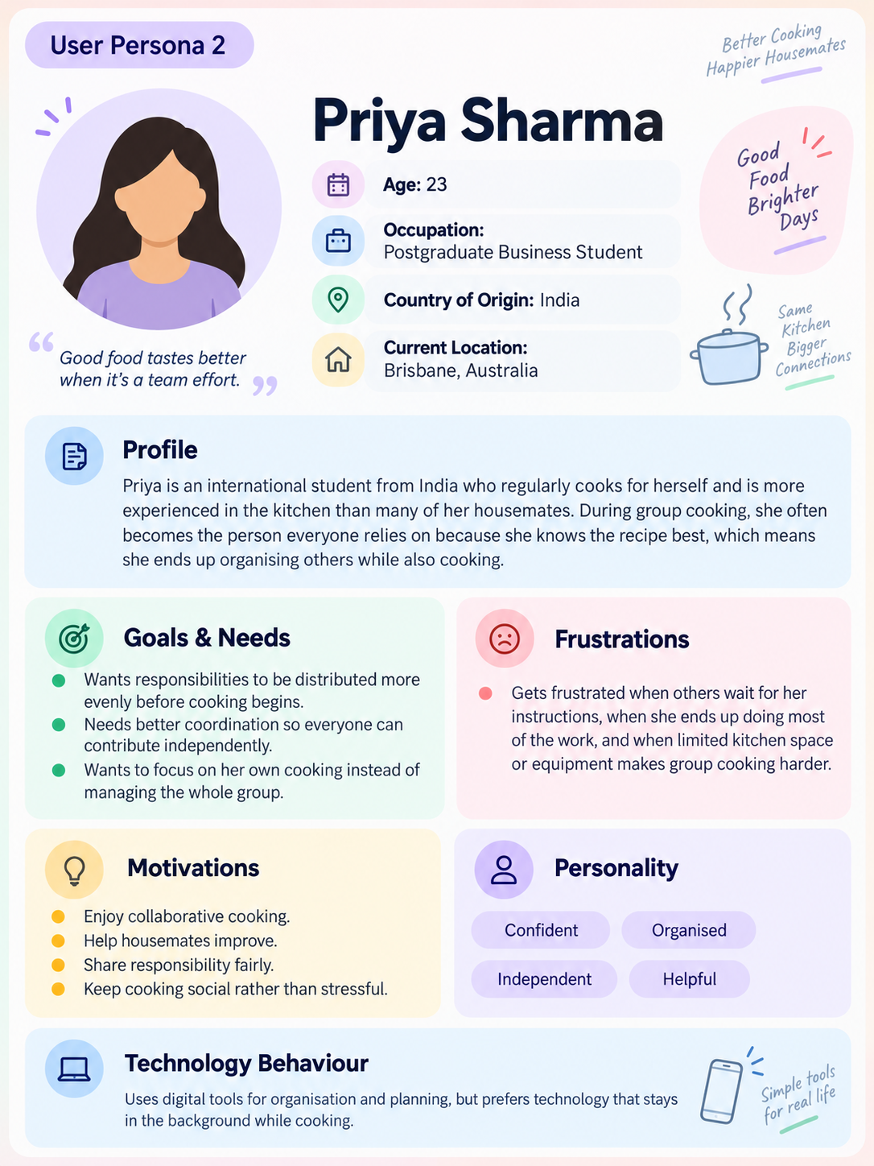

Theme 2 — Priya: Workload Falls on Whoever Knows the Recipe
User Story:
As a more experienced cook, I want cooking responsibilities to be divided fairly, so that I do not end up organising the group and doing most of the cooking myself.

Theme 3 — Both: Kitchen Space and Equipment Limit What’s Possible
Daniel’s User Story:
As a less experienced cook using a small shared kitchen, I want to know when and where I should complete my task, so that I do not get in the way of other people who are cooking.
Priya’s User Story:
As a more experienced cook in a shared kitchen, I want tasks to be coordinated around the available space and equipment, so that multiple people are not trying to use the same area or appliance at the same time.

